Step 1 --> Check the fraud score of the order.
1. Open the order. The first thing you will always see is the Information tab that always defaults to opening. In this tab you will find various information about the order, such as the Order Number, Order Date, the Status, Shipping type, Fraud score tools, Sub Total and tax break downs, shipping address, etc.
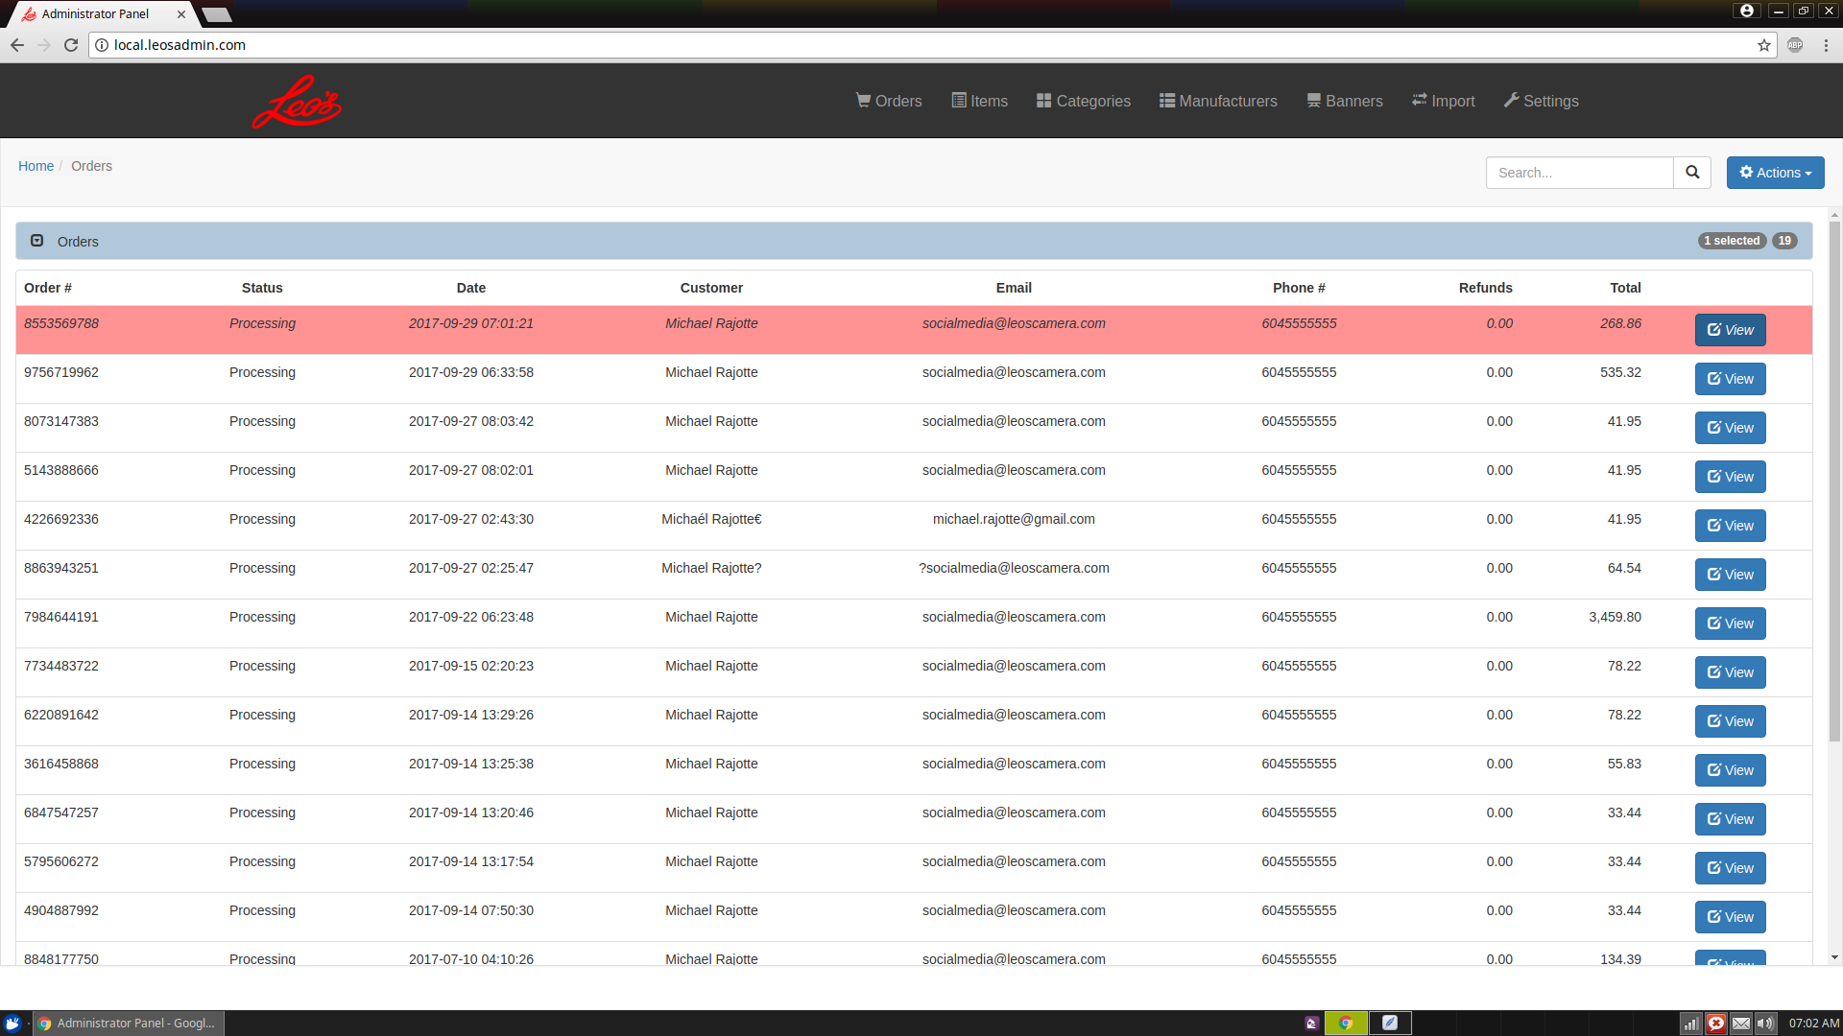
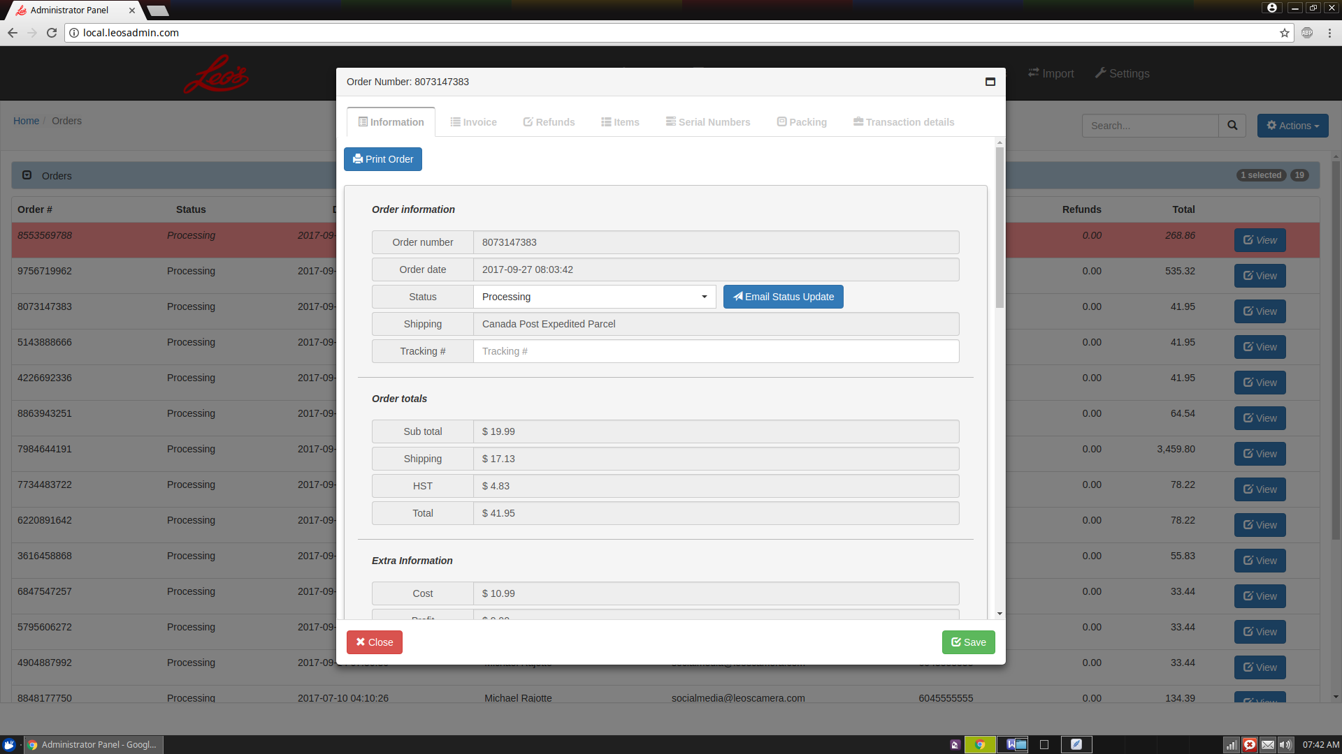

2. On a new order, the first thing you want to do is scroll down to the Fraud score section in the Information tab. The Fraud score will help aid you in determining the validity of a order. The Fraud score is broken down into several sections which the data can vary depending on which Payment Processor was used for the order, Moneris or PayPal.
3. If at any time using the Fraud score you feel something isn't quite right or the fraud score is high in the 60%+ range, like a first time order by somebody, or a AVS and CVD not matching if it's a Moneris Payment, then we should be following up on this order to check it's validity. Some steps you can take are.
**** If it is a Moneris order ****
(a). If it is a Moneris order, I would always call the card issuer bank and have them call the card owner to confirm the order purchase with us. When doing this, record any information call log number from the issuer bank and a name of the person you talked to and the date / time of the call.
(b). Call Moneris and have them repeat the same steps as above.
(c). Google map the shipping address, if it is going to a hotel, hostel or po box, be more suspicious.
**** If it is a PayPal order ****
(a). Call PayPal and have them confirm with the owner of the PayPal account if this order was made by them. Keep records of your contact with PayPal.
**** Moneris fraud score screen ****
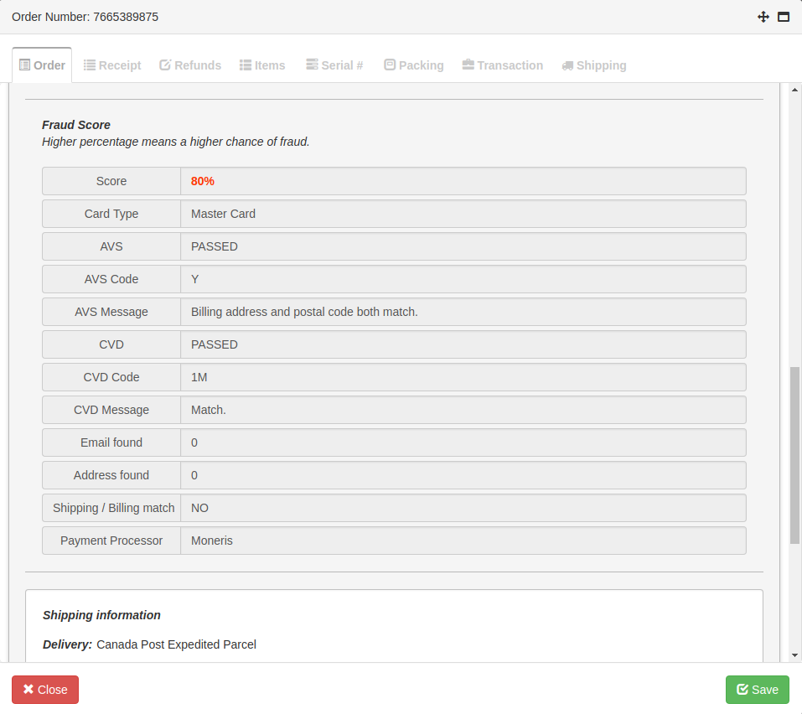
SCORE --> This will show you a percentage from 0% to 100%. The higher the percentage, then a higher chance of the order being fraudulent.
AVS --> Address verification System. When a order is processed, the Credit Card billing addressed given by the user is matched to the Credit Card, it will say either PASSED or FAILED. Failed means the billing address does not match the credit card. When a AVS fails, there is a REALLY high chance this is a fraudulent order, so take extra steps before proceeding (see below).
AVS Code --> This is the returned AVS result code from Moneris. The code is translated in the AVS Message for a explain of what it means.
AVS Message --> This is the result message of the AVS code. This tells you why the AVS passed or failed.
CVD --> This is the security code on the Credit Card. Usually it is the 3 digit number on the back of the card or the front. This just proves the card is in the hand of the user. It will either say PASSED or FAILED. Failure means a very high chance of fraud.
CVD Code --> The CVD result code returned by Moneris. The rCVD result message of this code is translated below in the CVD Message.
CVD Message --> The CVD message of the CVD Code. This tells you if the CVD matched, failed or did not process and why.
Email Found --> This will display a number. The system will scan our order history, and check to see if somebody with the email address that was provided during the ordering process has ordered from us before. If somebody has ordered 5 times from us in the past, this will display the number 5. You can use this to help determine if the person has regularly ordered from us, which helps prevent fraud.
Shipping / Billing match --> If the shipping address and billing address match, this will display YES. If they do not, it will display NO. A matching shipping and billing address greatly helps reduce fraud the vast majority of times, however do not rely on it 100% as sometimes very tricky fraudsters will steal somebody's identity and use the same shipping and billing address. You have to remember, sometimes people may need items ship to there non billing address for a variety of reasons, so even if they do no match, it does not mean it is fraud.
Payment Processor --> This shows which gateway was used to process the payment. At the moment it will either be Moneris or PayPal.
**** PayPal fraud score screen ****
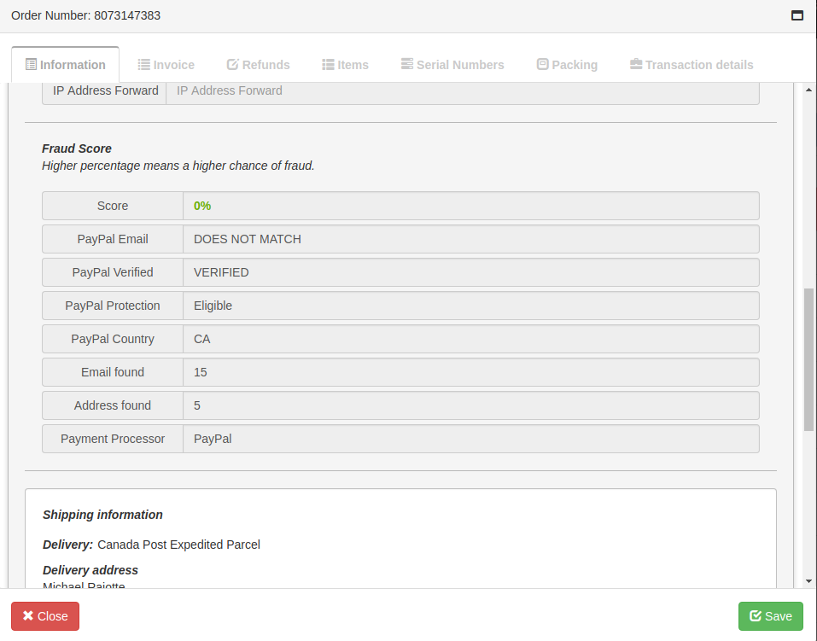
SCORE --> This will show you a percentage from 0% to 100%. The higher the percentage, then a higher chance of the order being fraudulent.
PayPal Email --> This compares the PayPal email address used to send the payment to the email address used for the order on our website. If they do not match, it will say DOES NOT MATCH. The common PayPal fraud is people accounts getting hacked and fraudsters using the hacked account to purchase things with. However, sometimes people use multiple emails for a variety of things.
PayPal Verified --> This will tell you if the PayPal account used to make the purchase was verified by PayPal. It will display either VERIFIED or NOT VERIFIED.
PayPal Protection --> This displays if this order is eligible for PayPal protection in cause of fraud. It will display either Eligible or Not Eligible. This is the most important part of PayPal process. If this is Eligible, then we are protected by PayPal from any fraud on this order. If it says Not Eligible, then we will not be protected against any fraud by PayPal. In my opinion, if this says Not Eligible, we should be taking extra steps to confirm this order (see below).
PayPal Country --> This tells us which country the users PayPal account originates from. For example: CA means Canada. Since at the moment we only ship to Canada at the moment. If this displays another country besides Canada, then be suspect of the order.
Email Found --> This will display a number. The system will scan our order history, and check to see if somebody with the email address that was provided during the ordering process has ordered from us before. If somebody has ordered 5 times from us in the past, this will display the number 5. You can use this to help determine if the person has regularly ordered from us, which helps prevent fraud.
Address Found --> This will display a number. The system will scan our order history and check if this PayPal address has purchased from us before. You can use this to help determine if this PayPal account has been used to purchase from us before in the past.
Payment Processor --> This shows which gateway was used to process the payment. At the moment it will either be Moneris or PayPal.

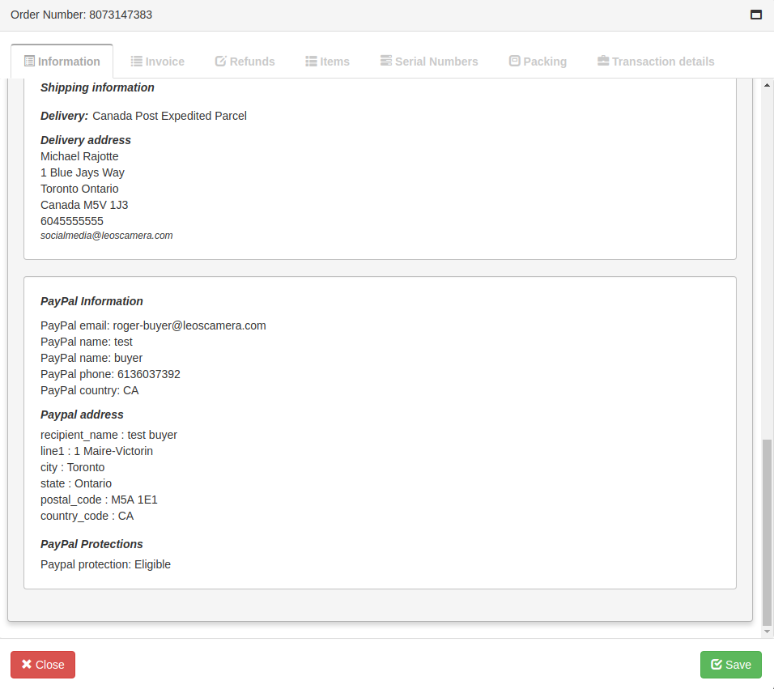
There will also be additional PayPal information displayed at the very bottom of the information tab, which provides you additional information on the users PayPal account.

Step 2 --> Print the order.
1. At the very top of the Information tab there is a Button to print the order information. This will give you several pages of information, some for our records and others to help you pack the order.
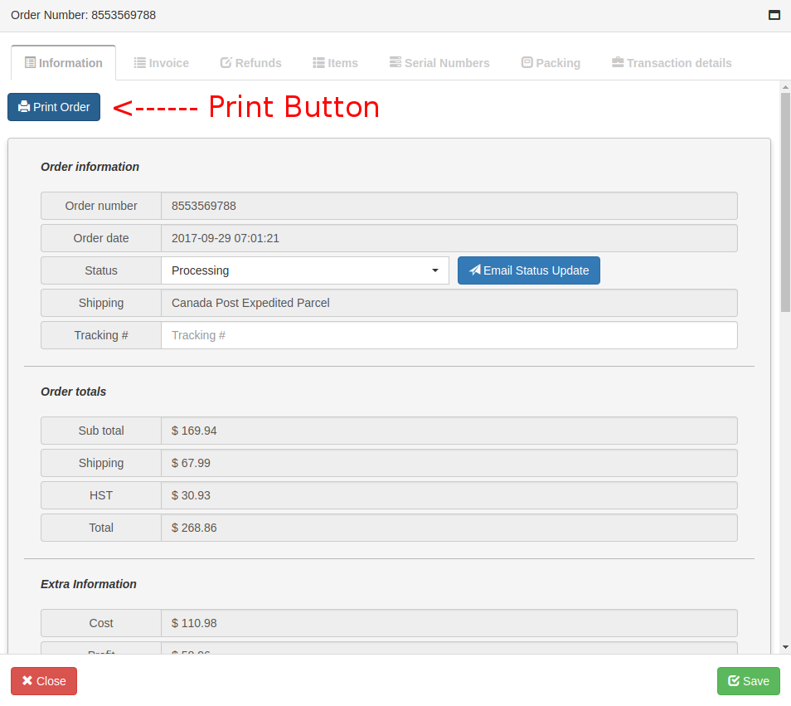
2. The first 2 pages of the order print out will be the receipt for the purchaser and a copy of our Return Policy. Copies of these 2 pages should be included and put into one of the boxes that is shipped to the purchaser.
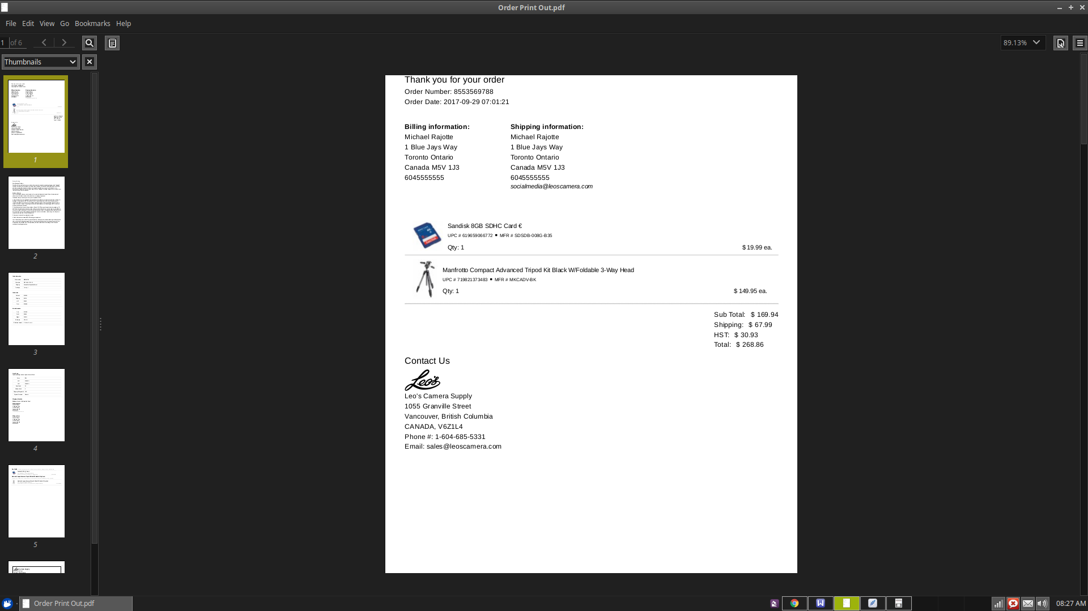
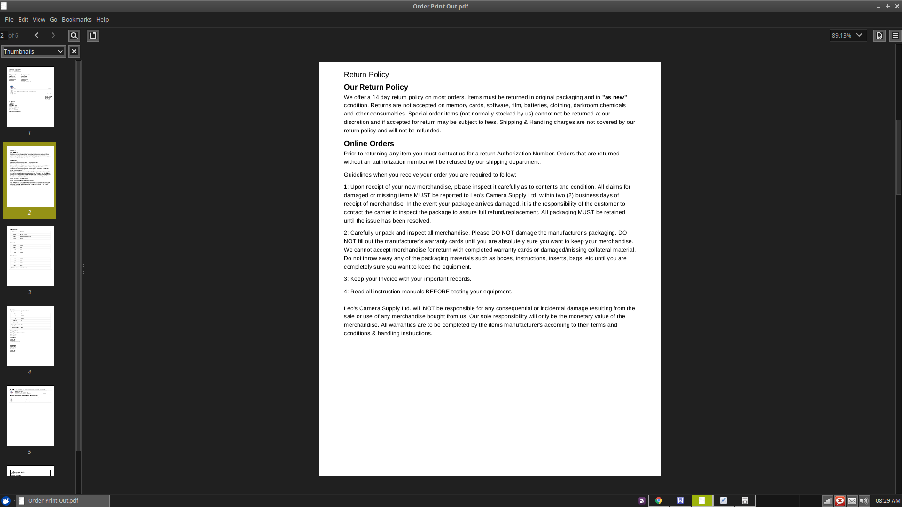
3. Pages 3 and 4 contains information such as the Shipping Type, Shipping Address, Fraud Score, Order Total and Costs break down. Keep these for our own records (perhaps in a file folder in the office?)
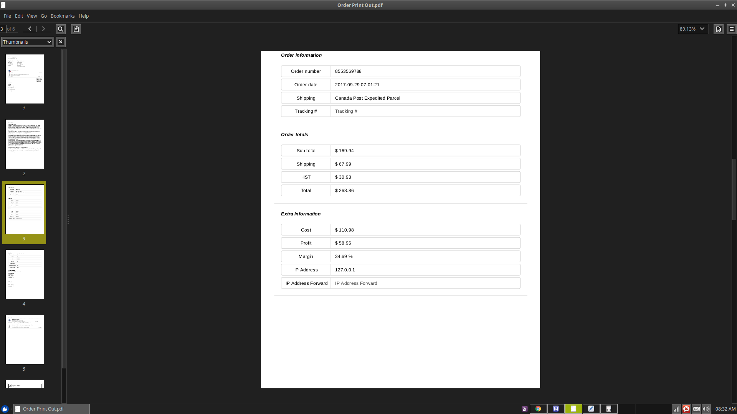
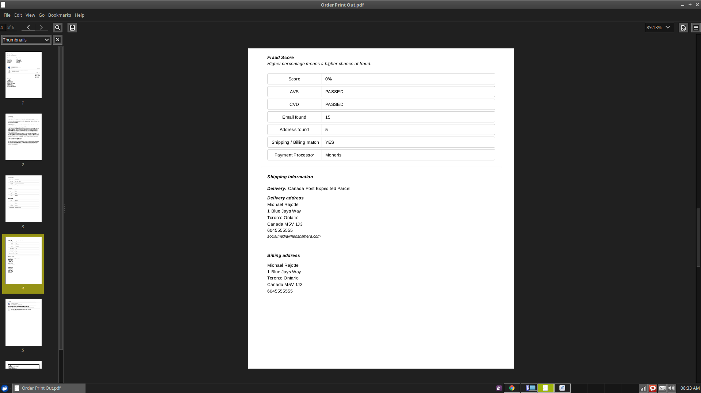
4. Page 5 of the printed order will show you how to pack the order. You can also view this information in the Packing Tab. Keep this for our records. See the next page for more details on how to pack a order.
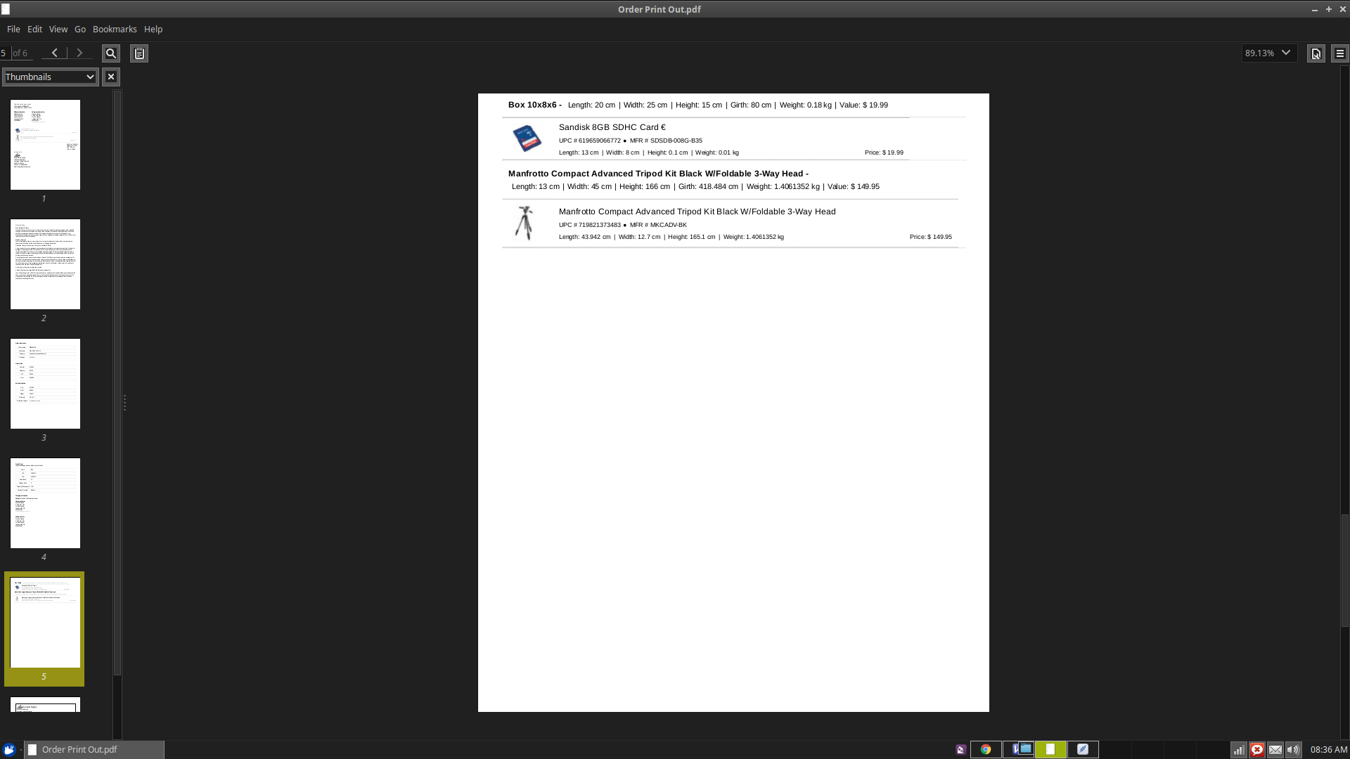
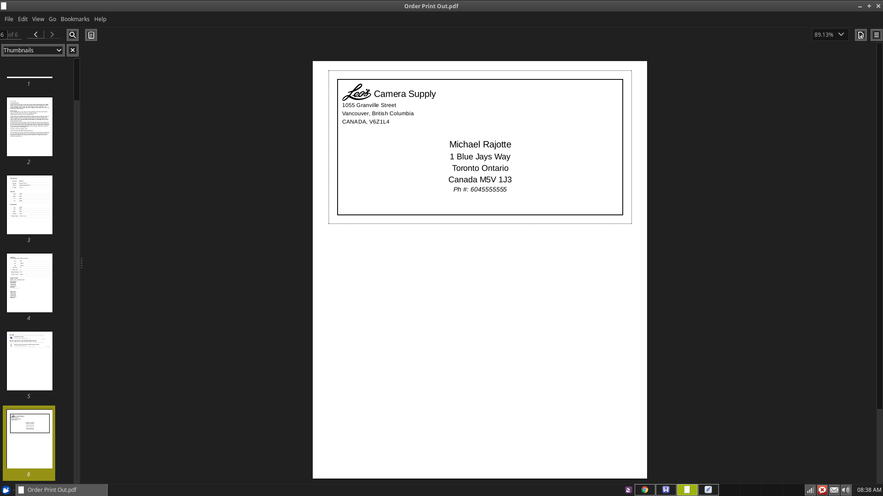
5. The very last page of the order print out will have a pre-generated shipping label for you to use, cut out, make copies etc.

Step 3 --> Packing the order.
The Packing Tab and or the packing print out will tell you how to pack the order. It tells you which items go in which box type and gives you the total weight and dimensions of each box fully packed.
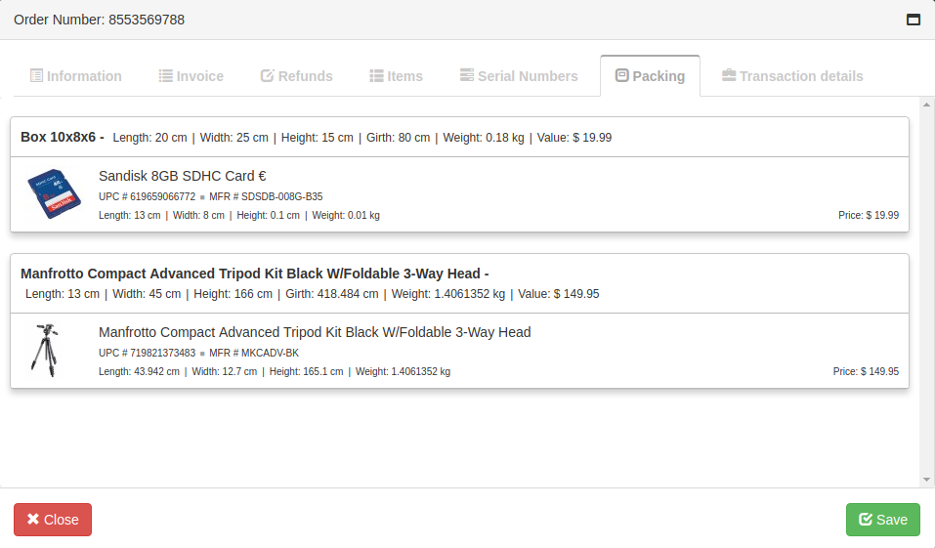
The packing algorithm takes the dimensions and weights of each item ordered and tries it’s best to fit them in the pre-determined sized boxes which are set-up in the Settings menu.
Some things to note. For example, Box 10x8x6 is the name of the box. It’s dimensions and weight fully packed are listed as Length: 20cm | Width: 25cm | Height 15cm | Girth 80cm | Weight: 0.18 kg. The total value of products in that box is $19.99.
Sometimes items may be too big to fit in the pre-determined sized boxes. In the example above, the tripod is too large to fit in any of the boxes, so the item is shipped separately by itself in the box it came in. In this case, you can wrap the box with paper if you wish to cover the outside labels, or ship it as is.
Do not forget to pack the printed receipt and return policy into one of the boxes.
Step 4 --> Recording any serial numbers.
If any of the items require the recording of any serial numbers, you can do this in the Serial Numbers tab. Each item will be listed, and you click on the + button to be prompted to enter a serial number for the selected item. A edit button is also provided to edit any existing serial numbers already added. Entered serial numbers will be displayed underneath the product You can add a unlimited amount of serial numbers to each item.
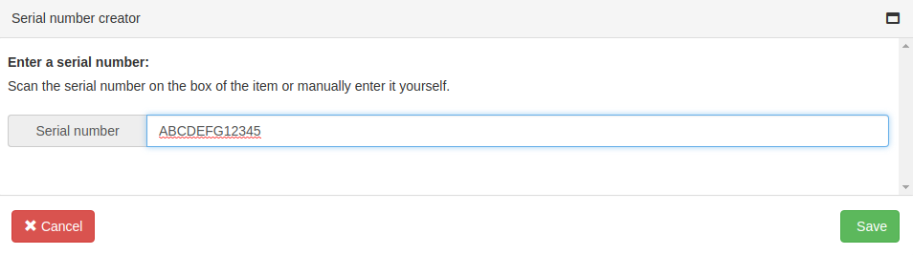
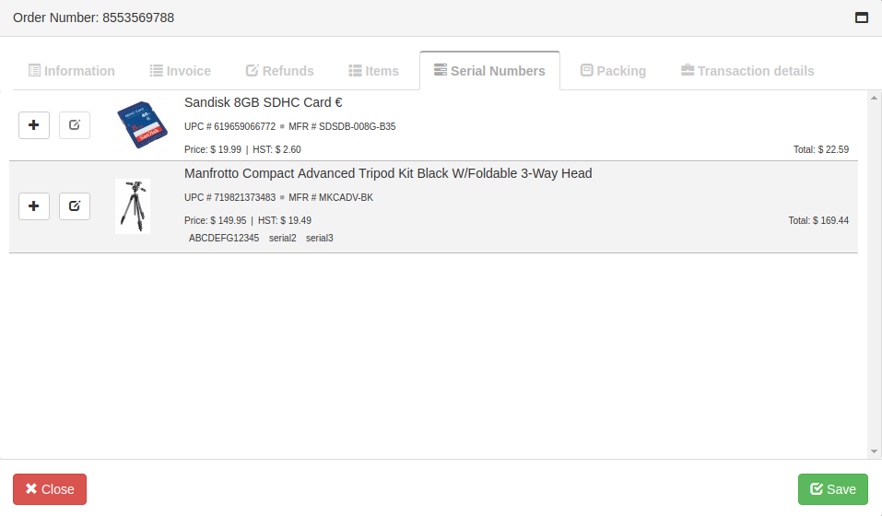
Step 5 --> Ship the order and update the status and tracking number.
After packing, preparing and shipping the order. Open the Information Tab of the order and update the Order Status. Orders that are in store pick up should be set to Ready for Pickup. Orders that are shipped should be set to Shipped. Shipping tracking numbers should also be entered into the Tracking # Field. After a order status has been updated, it is highly recommended to click on the Email Status Update button. This will send a email to the customer telling them the latest status of there order.
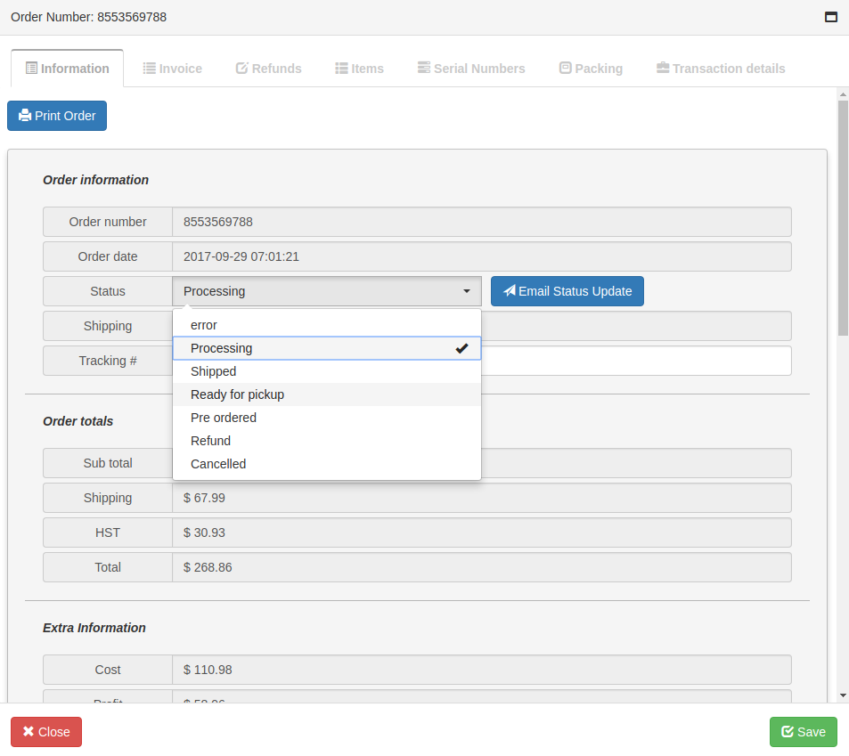
One thing to note, when updating the status, you need to click on the SAVE button for the status changes to be saved, including the recording of the tracking #.

